Step 1 : npm start and start JSON Server

JSON Server - npm install -g json-server

json-server --watch ./events.json --port 6700

Will open the link <http://localhost:3000/>

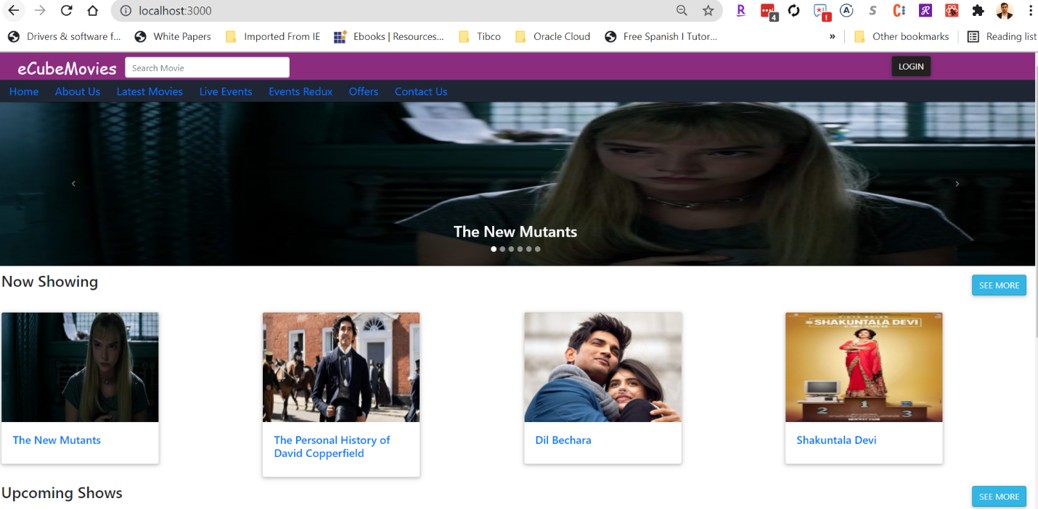

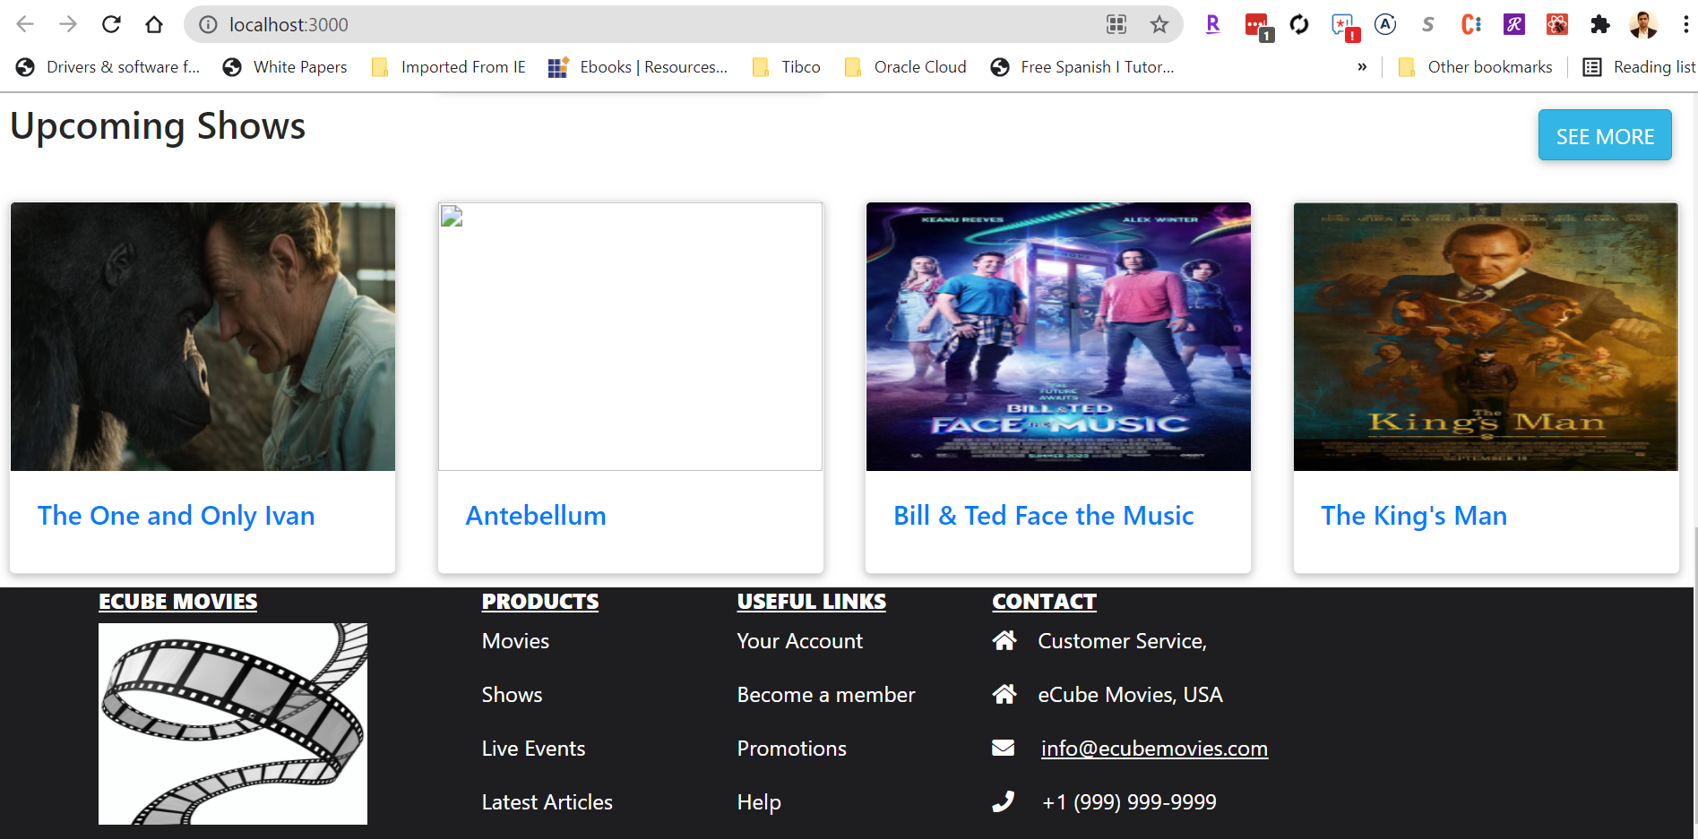

Step 2: Click on any Movie will Navigate to Detail View

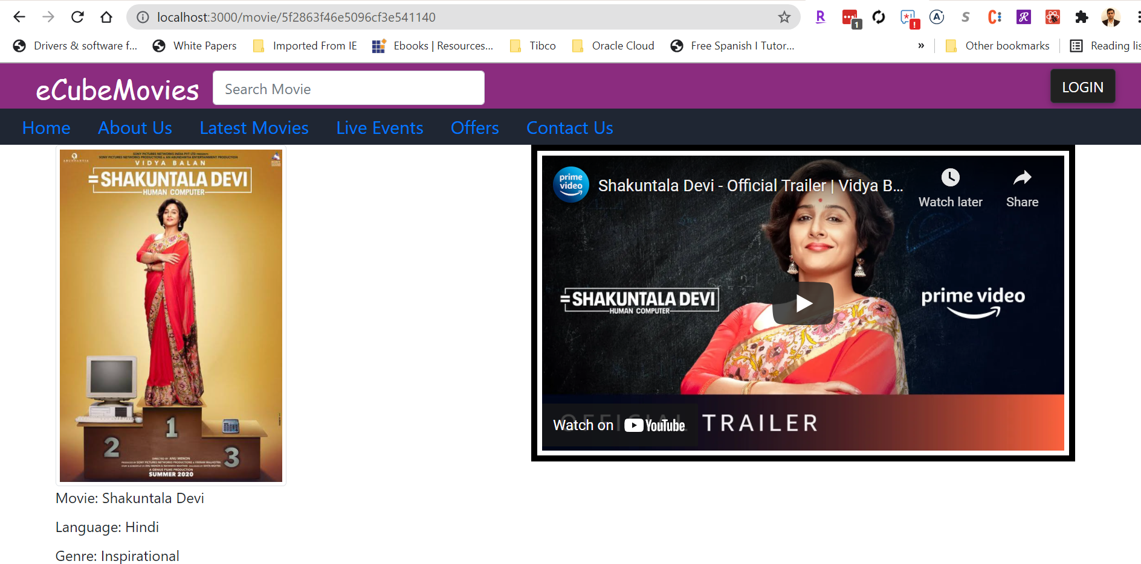

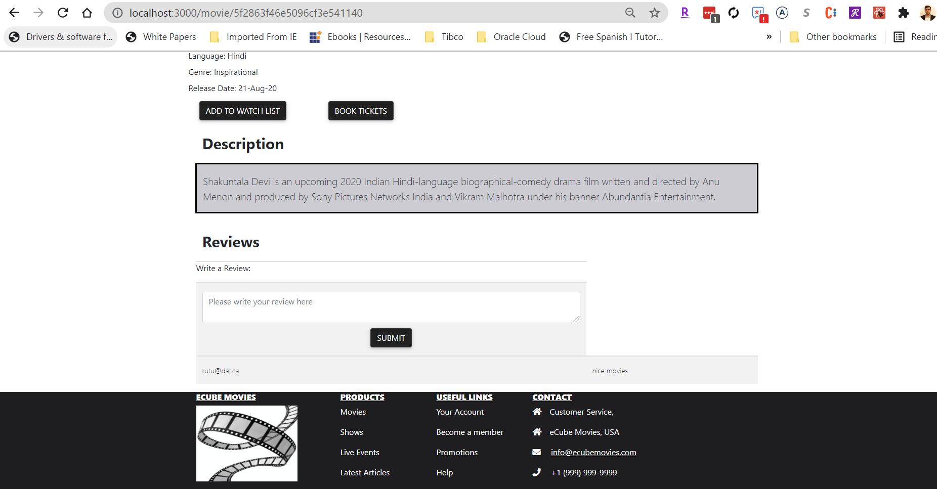

Step 3: Click on Book Tickets

Enter Booking Details and click select seat

Select Seat and click submit

Enter Payment Information

Click confirm

Click Ok

QR code will be displayed

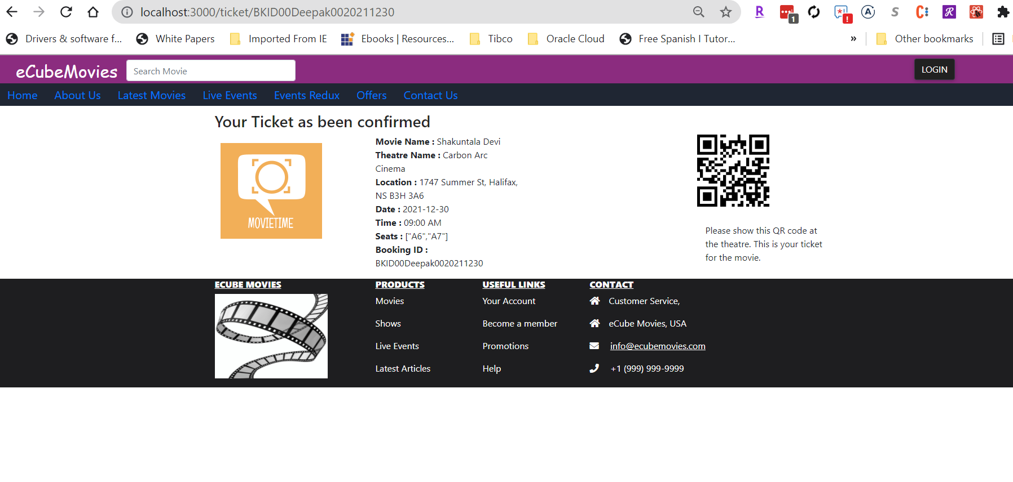

Fetch Events Using Redux – SAGA

Step 1 – On Header – Click Event Redux

Select Event and Click on Go to Details –

